CHAPTER 2-4

from FSM to operational systems

- An FSM is an abstraction. We can turn an FSM into an operational system in any of a number of ways:
  - An FSM can be translated into a circuit design and implemented directly in hardware.
  - An FSM can be simulated by software.

Simulating DFSMs directly

Ex2-4-1 L={w∈{a, b}*:w contains no more than one b}. L is accepted by the following DFSM M:
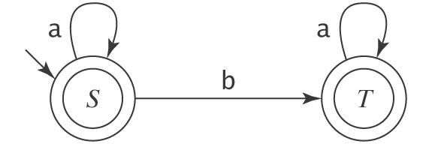
We can simulate M by the following program:
while (true)
{
S: c = getNextSymbol
if c == EOF then print "accept"
else if c == a then go to S
else if c == b then go to T
T: c = getNextSymbol
if c == EOF then print "accept"
else if c == a then go to T
else if c == b then print "reject"
}

- Using this approach, it is easy to write a program to simulate any DFSM.
- The biggest problem with the approach is that we have to write new code for every new DFSM.

Interpreting DFSMs

- Another approach is to write an interpreter that executes a DFSM directly.
- Here is a simple DFSM Interpreter:
dfsmSimulate(M: (K, Σ, δ, s, A):, w: string) =
st = s
do
{
c = getNextSymbol(w)
if c ≠ EOF then
if (δ(st, c) exists) then st = δ(st, c) else reject
} while c != EOF
if st ∈ A then accept else reject
- The algorithm does not build the entire machine; it merely follows the path traversed by the input strings through the machine, building a state on the fly when necessary.
- The advantage of this approach is that the same program can be used to simulate any DFSM.
- The homework problem is to translate the above algorithm into Java.
- δ(st, c) = y means that if the machine is in state st and the input letter is c, the machine will move to state y.
- δ(st, c) does not exist, it means that if the machine is in state st and the input letter is c, the machine will move to the dead state.

Homework problems

- Write a Java program to read in a DSFM, then decides if an input string is accepted by the DSFM or not. You can assume the input DSFM is legal, and states are named with single letters.
Note:
- The program has 2 parts:
    - Read in the start state, the final states, and the transitions of the input DSFM. (no need to read K or Σ since the transitions would imply those).
    - Use a Vector<String> to store the set of final states.
    - Use a Vector<String> to store the set of transitions.
- Determine if an input string is accepted or rejected based on algorithm dfsmSimulate.
    - String methods such as startsWith and substring are useful.
- The following run is for the DSFM described in Ex2-4-1:
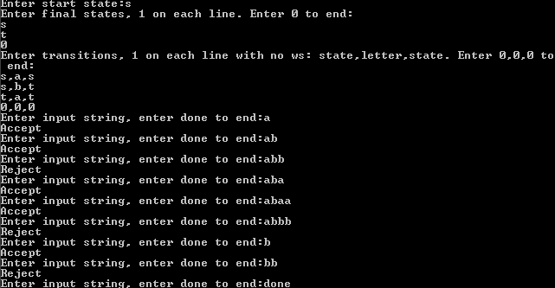

Submit the file DSFM.java via Google Classroom.

